# Workflow B: DILI

# Preliminary Narrative & Results

## User Persona

Paul Watkins, MD, is a faculty member at UNC Chapel Hill, with multiple academic appointments, including: Professor of Department of Environmental Sciences and Engineering, Gillings School of Global Public Health; Howard Q. Ferguson Distinguished Professor, Eshelman School of Pharmacy; and Director, Institute for Drug Safety Sciences. His primary area of expertise is hepatology and hepatotoxicity, specifically, drug-induced liver injury. Dr. Watkins has a long history of funding from NIH, the pharmaceutical sector, and non-profit organizations, including the international DILI Network, for which he serves as UNC PI and Steering Committee member.

Dr. Watkins learned about Translator through members of the Exposures Provider and Ranking Agent teams and was invited to attend a hackathon. Subsequent meetings led to a collaborative proposal with the DILI Network Steering Committee. Specifically, Dr. Watkins and the DILI Network Steering Committee are interested in using Translator to suggest plausible biological mechanisms that might justify a clinical trial on DILI. They have empirical evidence on the effectiveness of steroids and antioxidants and would like to use Translator to provide mechanistic insights into the biological plausibility of these drugs or others in the treatment of DILI and DILI-related outcomes such as liver transplant and chronic DILI.

## Translator Query and Answers

As a first step in exploring potential drugs for repurposing for DILI, Translator team members constructed a [three-hop query](https://github.com/NCATSTranslator/minihackathons/blob/main/2021-12_demo/workflowB/InitialARSQuery_MESH:D056487) that asked *what chemical substances are associated with chronic DILI by way of genes?*

The query was submitted to the ARS and Expander Agent’s ARAX returned 500 results (the default maximum). (PK = f02e762d-de0d-4069-935c-a6ed821998ac)

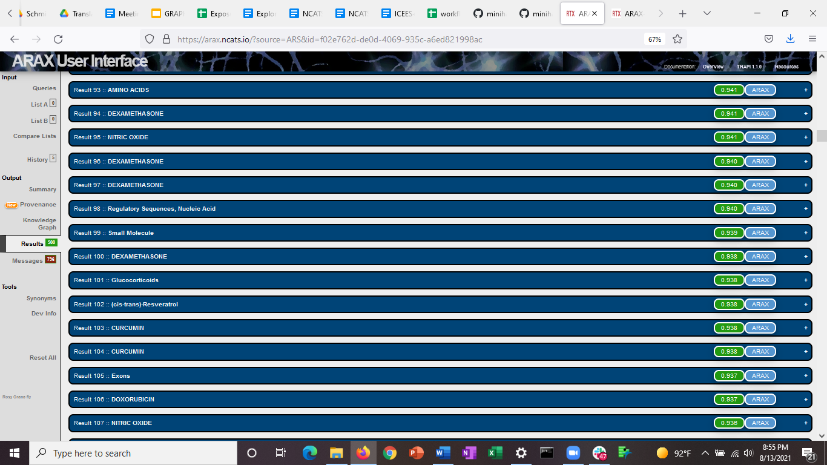

A review of the results found that dexamethasone was suggested in 34 answers, glucocorticoids were suggested in 16 answers, and curcumin was suggested in 24 answers. Most of the other answers returned hits like 5’ flanking genes and exons that are related to the query, but not the intent of the user. (See Conclusion and Next Steps.) Regardless, the results that were returned were promising, as dexamethasone is one of several steroids belonging to the broader class of glucocorticoids. Curcumin is a spice that has been used for centuries in certain Asian cultures and is the active ingredient in turmeric. Translator’s description states:

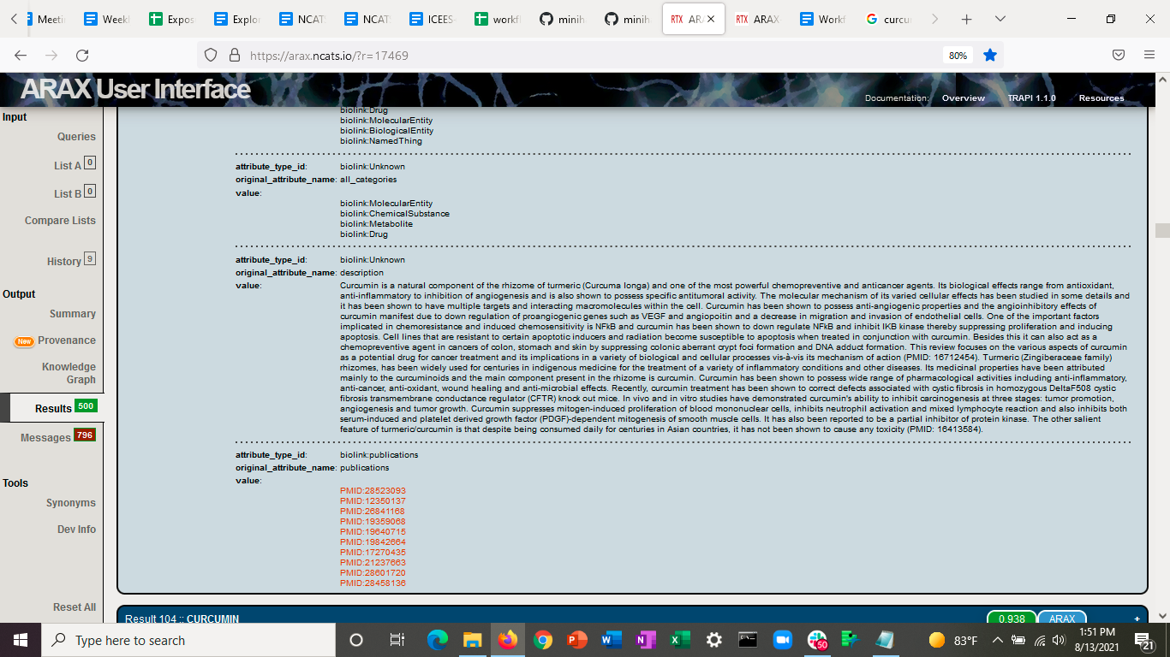

A review of the knowledge graph shows identifies several diseases or phenotypic features that are associated with chronic DILI, including DILI, non-alcoholic fatty liver disease, alcoholic liver disease, drug-induced hepatitis, Hepatitis A infection, primary sclerosing cholangitis, Gilbert Syndrome, and Stevens-Johnson syndrome. A review of the provenance indicates that these answers were contributed by ICEES DILI KP, which is an open clinical knowledge source that exposes clinical data on DILI from the DILI Network, contributed as part of their collaborative proposal with Translator. The fact that the answers were from the ICEES DILI instance is not surprising because the query itself targeted the Translator clinical KPs, but the fact that the answers included those diseases and phenotypes that are highly correlated in the underlying DILIN dataset is reassuring and indicates that the query was implemented as intended.

Among the genes that were returned are several that are related to inflammation and the immune system, including *IL1B* (which encodes the cytokine interleukin-1beta)*, TNF* (which encodes the cytokine tumor necrosis factor)*, FASL* (which encodes Fas ligand)*, CCL2* (which encodes chemokine ligand 2)*,* and *TLR4* (which encodes toll-like receptor 4). The protein products of these genes are involved in recruitment of neutrophils and other types of innate immune cells, apoptosis or programmed cell death, and a variety of other aspects of inflammation and innate immunity. These answers were largely from RTX KP and SemMedDB.

Several of these genes are associated with all three of the potentially interesting drugs or compounds, namely, dexamethasone, glucocorticoids, and curcumin by way of an association with non-alcoholic fatty liver disease and drug-induced hepatitis.

Shown below are example answers for *TNF*.

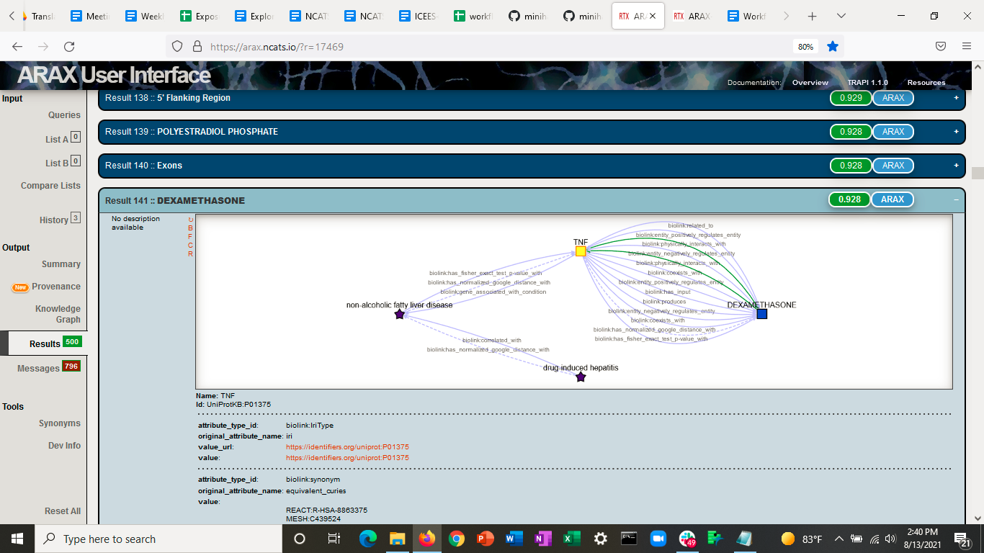

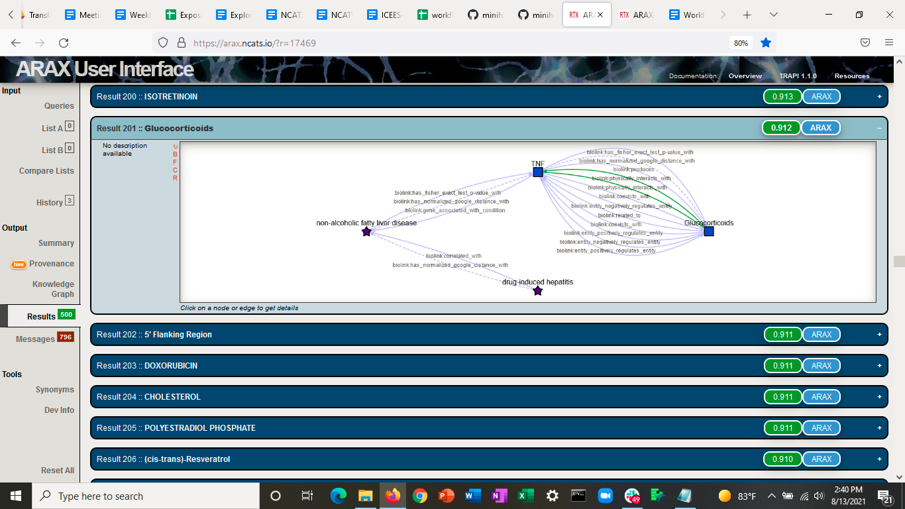

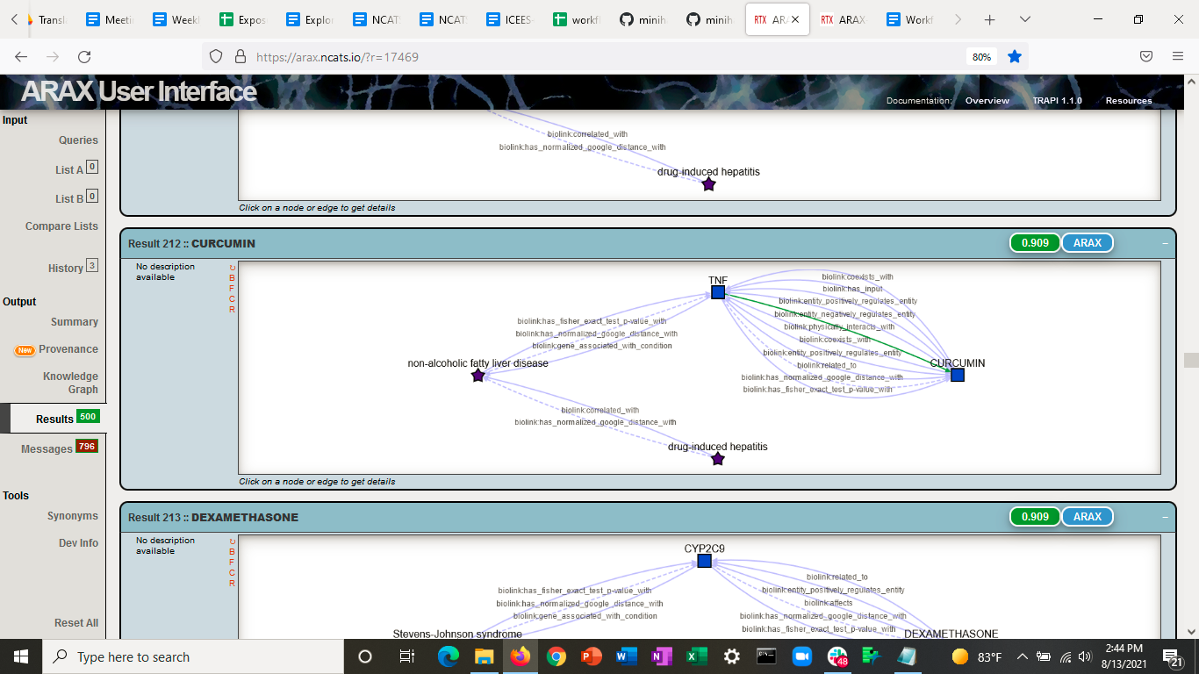

## Conclusion and Next Steps

Translator provided evidence to support anecdotal observations on the effectiveness of steroids and antioxidants, specifically, dexamethasone and curcumin, as potential treatments for chronic DILI. Translator further provided a plausible mechanistic rationale to explain how those drugs might treat chronic DILI.

Ongoing work includes: a deeper dive into the answers to the query described here and related ones, as well as the execution of new queries designed to refine the initial query by taking advantage of Translator operations and qualifiers that might improve the ranking of answers and filter out erroneous answers such as 5’ flanking region and exons.